玩沙

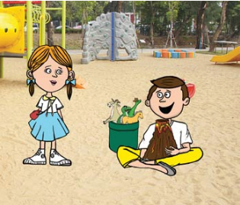  你好，你在玩什么？  Hello! What are you playing?  你好，你要不要跟我玩？  Hello! Do you want to play with me?  好！Yes! | 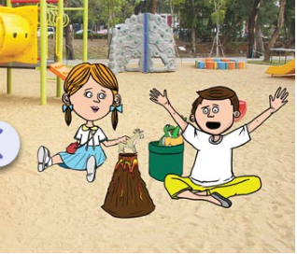  这是火山。很大的火山。This is a volcano! A very big volcano.  好，羊在山上。The goat is on the volcano.
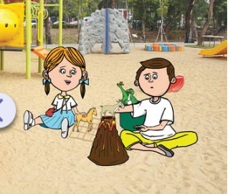  这里是田。马在田里。This is a field. The horse is in the field. | 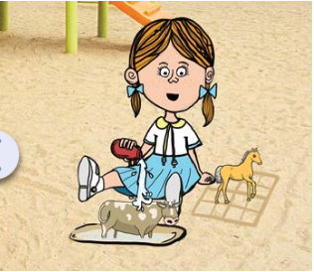  这里是水。牛在水里。There is water here. The cow is in the water.
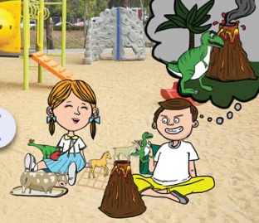  我很喜欢这里。I like this place very much.  这是我的火山。  This is my volcano. | 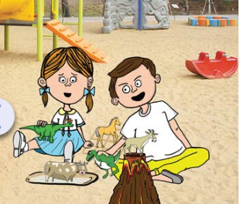  我很喜欢吃牛。你要不要吃？  I really like to eat cows. Do you want some?  不，不，不。No,no,no.
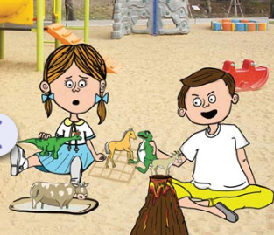  我很喜欢吃马。你要不要吃？I really like to eat horses. Do you want some?  不要，不要。我不吃马。  No,no. I don’t eat horses. | 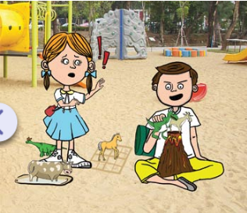  我很喜欢吃羊。你要不要吃？I really like to eat goats. Do you want some?  不，我不吃羊。不要吃我的羊。No. I don’t eat goats. Don’t eat my goat
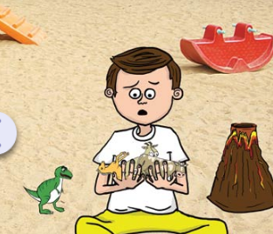  你不要吃羊，不要吃马，不要吃牛，你要吃什么？You don’t want to eat horses, cows, or goats. What do you want to eat? | 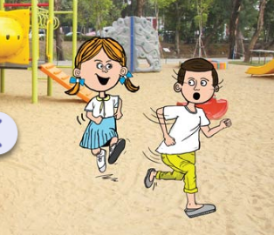  我喜欢吃男生。I like to eat boys!

家长签名 Parent's signature
Please sign and send it back to school in the homework folder.
 | 星期四  Thursday | 星期五  Friday
第一次
1st time
第二次
2nd time
Please go to our class website to see the video of this week’s reading. Let your child read with my video. There is also the English version of this reading in case you need it.

